OWASP Juice Shop Pentesting Report
Author: Nathan Mascarenhas
Date: Fall 2025

Table of Contents
1. Introduction
2. Tools Used
3. Methodology
4. Findings
5. Remediation Recommendations
6. Appendix: Screenshots & Proofs

1. Introduction
This report documents penetration testing activities performed on the OWASP Juice Shop vulnerable web application. The primary objective of this engagement was to identify and exploit web application vulnerabilities to demonstrate common security weaknesses and understand attacker methodologies in a safe, legal environment.

2. Tools Used
Tool | Purpose
OWASP ZAP | Intercepting traffic, passive/active scanning
Burp Suite | Manual testing, repeater, intruder
Browser DevTools | Element inspection, JS debugging
Docker / Node | Hosting Juice Shop instance

3. Methodology
Testing followed a structure similar to the OWASP Top 10 methodology. The assessment included reconnaissance, traffic interception, scanning, manual exploitation, validation, and documentation of vulnerabilities. All findings in this report are reproducible and include proof-of-exploit evidence.

4. Findings

4.1 Score-Board
Description | Finding the hidden scoreboard page. I did this by looking at the developer tools in the javascript file, I looked for any reference to “score board” and I found a path that had “score-board” in it. I typed that in the URL and I was able to find the page.
Impact | ...
Steps to Reproduce | 1. Check Developer tools for the main.js file. Use beautifier.io to clean up the code.  2. Search for “score board”  3. Type the “score-board” path at the end of the URL
Evidence (Screenshot / Output) | Check Appendix
Severity | Low / Medium / High / Critical

4.2 Reflected Cross-Site Scripting (XSS) in Search Function
Description | A reflected Cross-Site Scripting (XSS) vulnerability was identified in the application's search functionality. The search parameter is processed and returned to the user without sufficient sanitization or encoding. As a result, an attacker can craft a malicious URL that injects untrusted JavaScript into the webpage when a victim clicks the link.  Because the server renders user-controlled input directly into the HTML response, arbitrary script execution is possible in the victim's browser.
Impact | Successful exploitation allows an attacker to execute JavaScript in the context of the affected web application. This enables:  - Theft of session tokens or authentication cookies  - Execution of actions on behalf of the user (CSRF-like behavior)  - Redirection to malicious websites  - Defacement or manipulation of webpage content  - Collection of sensitive information from the DOM  If an authenticated user (especially an admin) interacts with a malicious link, the attacker may obtain elevated access or perform privileged actions.  This makes XSS a serious security risk even when limited to a search bar.
Steps to Reproduce | 1. Open search bar  2. Type in code that has a javascript or html tag  3. Watch the website execute the code, instead of treating it like text
Evidence (Screenshot / Output) | Check Appendix
Severity | Low / Medium / High / Critical

4.3 Exposed Metrics
Description | The application exposes a Prometheus-style metrics endpoint without authentication or access controls. This allows any unauthenticated user to view detailed internal system information, increasing the risk of reconnaissance, exploitation, and application misuse.
Impact | If exploited, an attacker could:  Profile backend architecture and internal paths  Identify performance issues or bottlenecks to exploit  Determine service versions, enabling version-specific attacks  Observe error messages and stack traces  Infer user activity patterns or spike times  Gather information useful for DoS attacks  Leverage internal metrics names to help craft payloads  Gain insight into dependencies (e.g., Redis, MySQL, Postgres)
Steps to Reproduce | 1. Discover Prometheus’ default path for user data metrics  2. Type that path in the search bar  3. ...
Evidence (Screenshot / Output) | Check Appendix
Severity | Low / Medium / High / Critical

4.4 SQL Injection – Login as admin
Description | During testing, the login form was found to construct SQL queries using string concatenation with unsanitized user-supplied input. This approach allows attackers to inject SQL operators into the query and manipulate its logic.  Juice Shop uses a raw SQL query for the challenge’s login mechanism. When a malicious payload is submitted in the email field, the generated SQL query becomes logically true regardless of the provided password.
Impact | A successful exploit allows an attacker to:  - Log in as any user, including the administrator  - Access user account information  - Modify or delete data  - Perform privileged operations  - Potentially chain this vulnerability with others (e.g., data exfiltration)  Because authentication is completely bypassed, this vulnerability has one of the highest possible impacts in a web application.
Steps to Reproduce | 1. Go to the login page  2. Enter : ‘ Or True --  3. Enter any string in the password field (it is ignored).  4. Log in
Evidence (Screenshot / Output) | [Insert Image]
Severity | Low / Medium / High / Critical

4.5 Vulnerability Name Here
Description | ...
Impact | ...
Steps to Reproduce | 1. ...  2. ...  3. ...
Evidence (Screenshot / Output) | [Insert Image]
Severity | Low / Medium / High / Critical

5. Remediation Recommendations
This section outlines recommended fixes based on industry best practices, including secure input validation, improved authentication mechanisms, stronger access controls, and safer API design.

6. Appendix: Screenshots & Proofs
1. Scoreboard Challenge
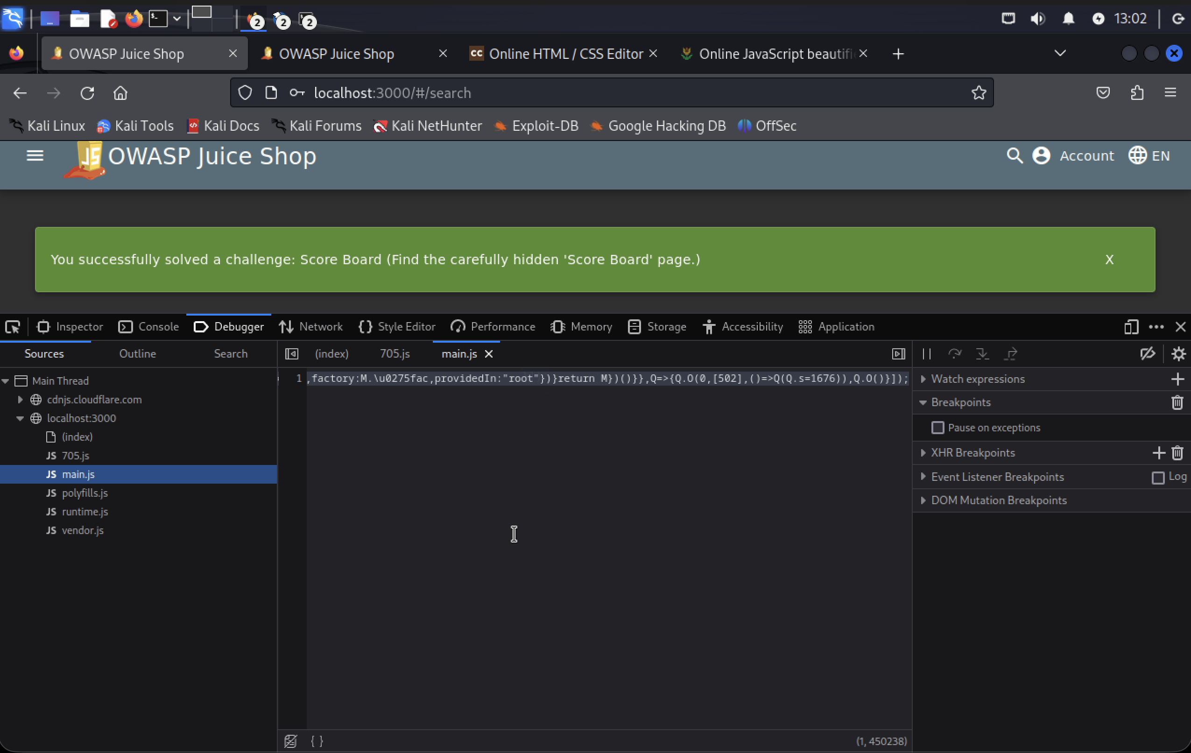

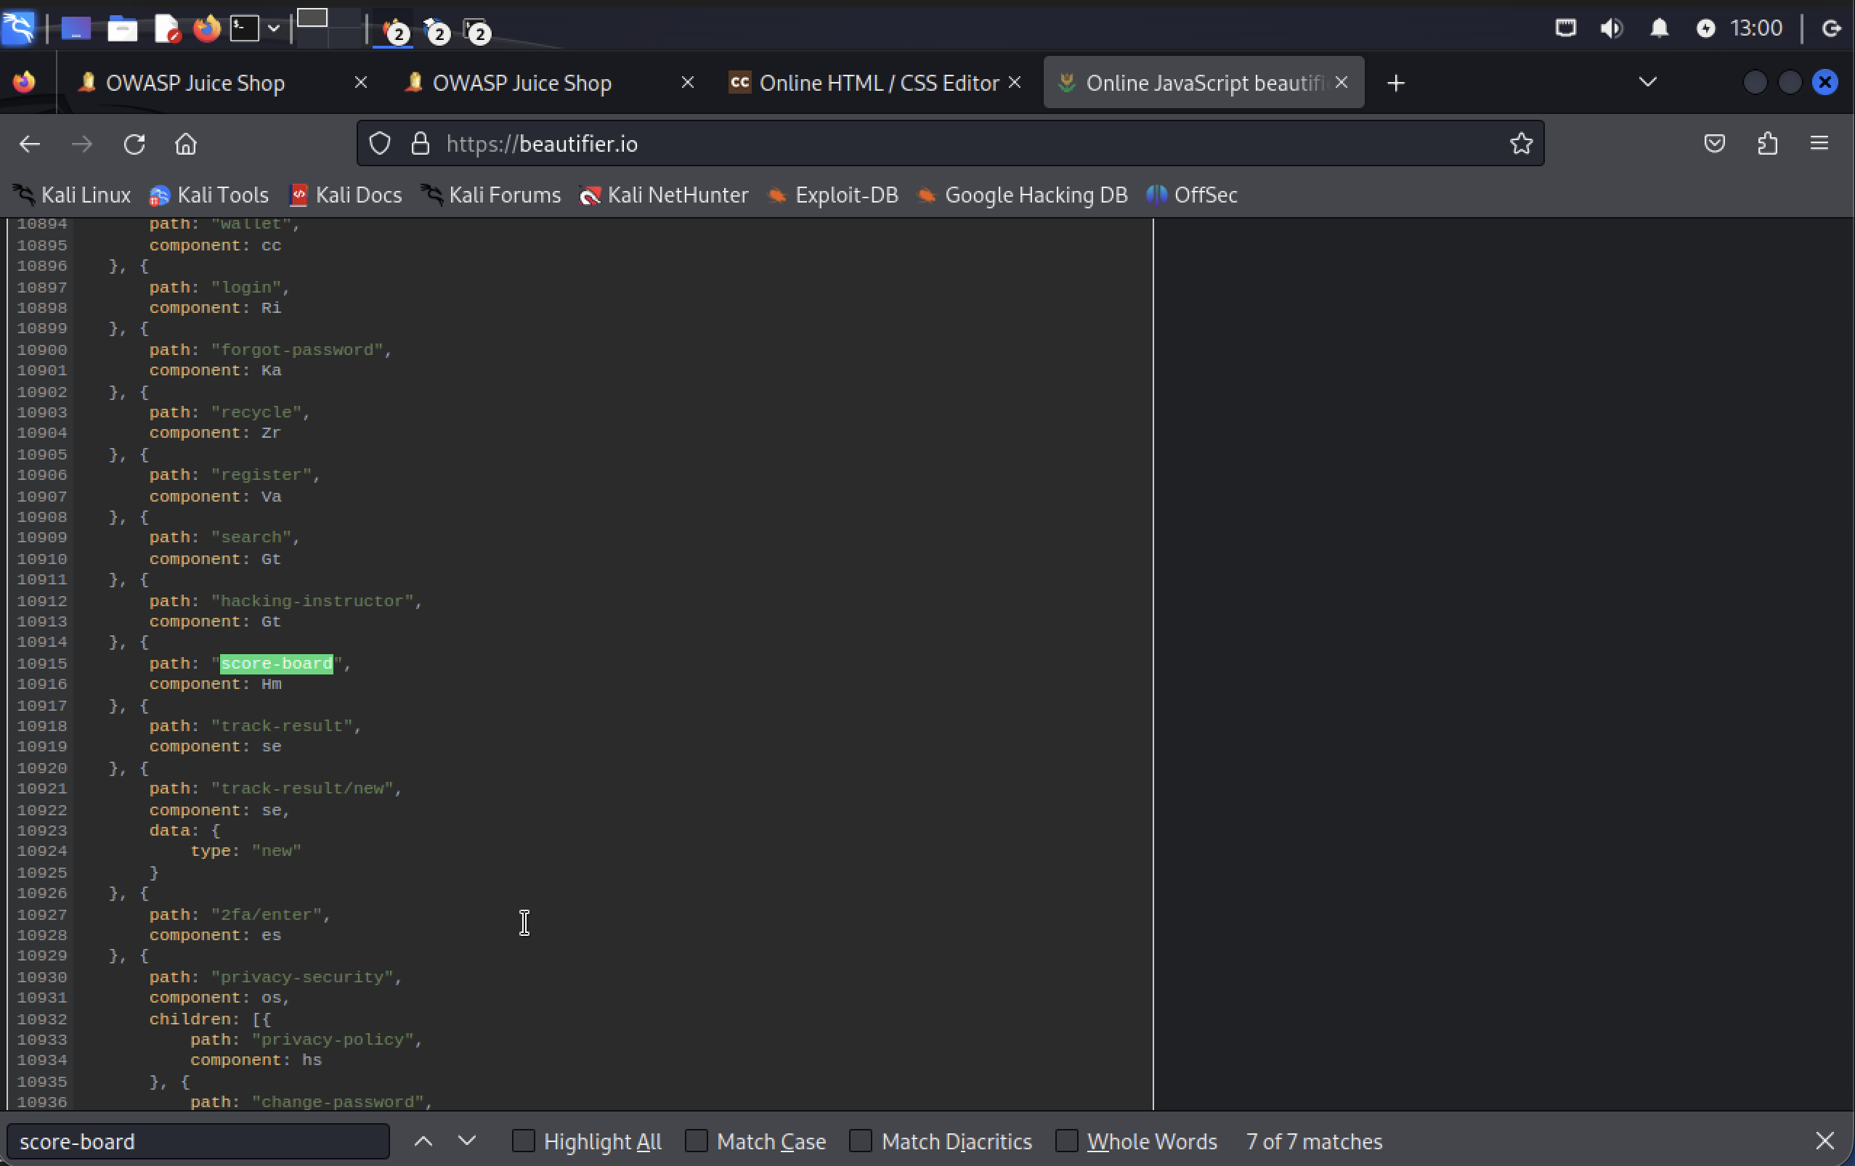
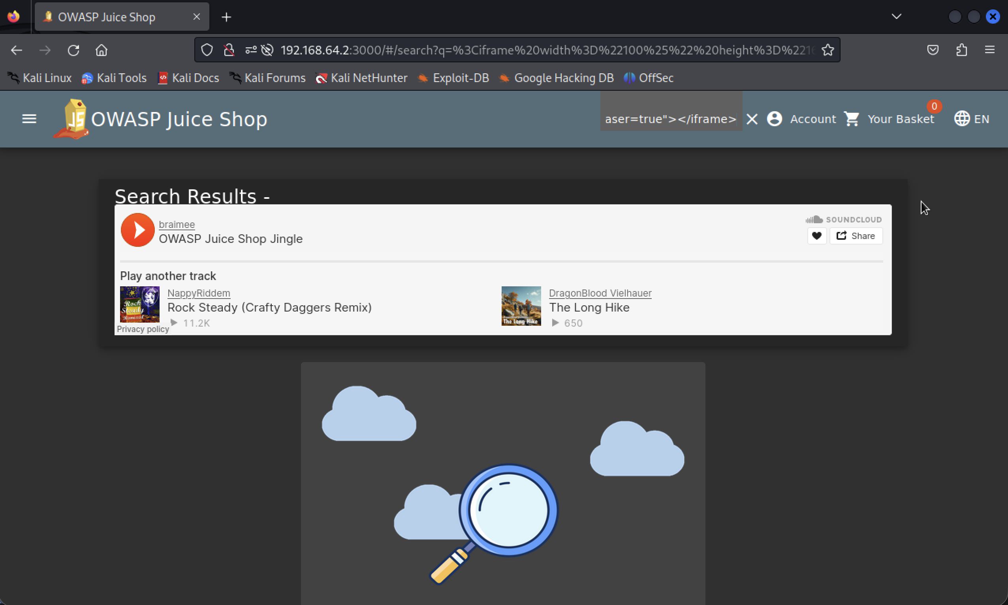
2. Cross-Site Scripting (XSS) in Search Function

3. Exposed Metrics Endpoint Vulnerability
